BIO101 LAB REPORT

Group -1



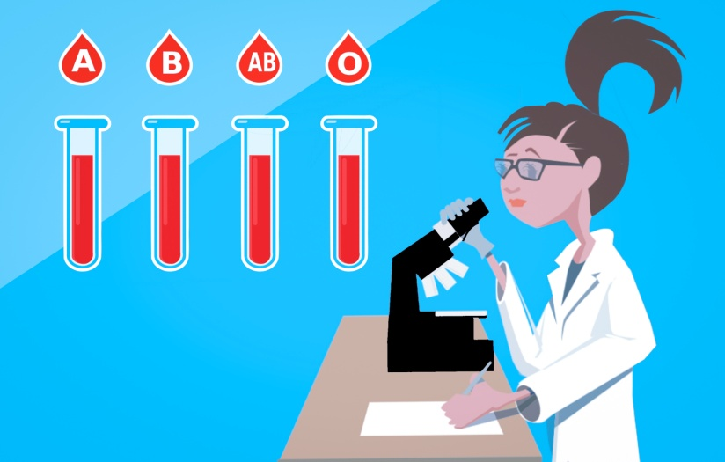

Name : Srejon Ahamed Joy

Id : 21301354

Section : 2

Date : 20 - 02 -2023

Submitted to : Md Asaduzzaman Khan

**Name of Experiment**: ABO Blood Group Determination.

**Purpose of Experiment**: The purpose of the blood group test is to determine an individual's blood type and knowing the procedure of a blood test. Furthermore, familiarize with the fundamental principles of ABO blood group.

**Principle:** Blood is a critical fluid that flows throughout the human body, transporting oxygen, nutrition, hormones, and other necessary chemicals to all organs and tissues. It also helps eliminate waste products and carbon dioxide from the body. Blood consists of many cell types floating in liquid called plasma, which includes proteins, electrolytes, and other chemicals. A blood group, also known as a blood type, is a categorization system that divides a person's blood into groups based on the presence or absence of particular antigens and antibodies on the surface of red blood cells. The presence or lack of A and B antigens on red blood cells determines the four major blood groups: A, B, AB, and O. Furthermore, the Rh factor, a protein on the surface of red blood cells, can be present or absent, dividing the population into two subgroups: Rh-positive and Rh-negative. The ABO blood group system is the most widely used categorization system, and it is critical in medical operations like blood transfusions and organ transplants. Blood group testing is a straightforward and normal operation that lets healthcare providers determine an individual's blood type, allowing them to administer safe and effective therapy.

|  |  |  |  |  |
| --- | --- | --- | --- | --- |
| **Blood Group** | **Antigen** | **Antibody** | **Donation** | **Receive** |
| AB | A and B | None | AB | All |
| A | A | Anti B | A and AB | A and O |
| B | B | Anti A | B and AB | A and O |
| O | None | Anti A and Anti B | All | Only O |
| Rh(+ve) | D | None |  |  |
| Rh(+ve) | None | Anti D |  |  |

**Materials:**

1. Blood collection kit
2. Blood typing reagents
3. Glass Slide
4. Toothpick(Mixing Sticks)
5. Cotton
6. Hexisol
7. Blood Sample
8. Lancet
9. Pushing Pen

**Procedure:**

* At first we need to ensure that the particular finger of the person whose blood will be tested is properly cleaned with alcohol. By this process we can derive germs from the finger and will be able to get an appropriate test result.
* Throughout this process we must be careful that his particular finger not touches anything.
* After ensuring top 2 points we need to make a small hole with the help of pushing pen and make sure that blood is coming out from the hole.
* Then we will take 3 drops of blood in a single glass slide but in three different parts that are divided by red marks.
* After taking blood samples we need to clean the particular area of the finger with alcohol.
* Now, we will add three types of reagents (Anti A serum, Anti B serum, Anti D serum) in three different parts of the glass slide.
* To remember which reagent added in which part we can name the part by the name of reagent with the help of red marker.
* On the next step we will mix the blood samples with blood serums carefully with the help of toothpicks.
* We need to use three different toothpicks to get the proper result
* After waiting for a minute we can see the difference.

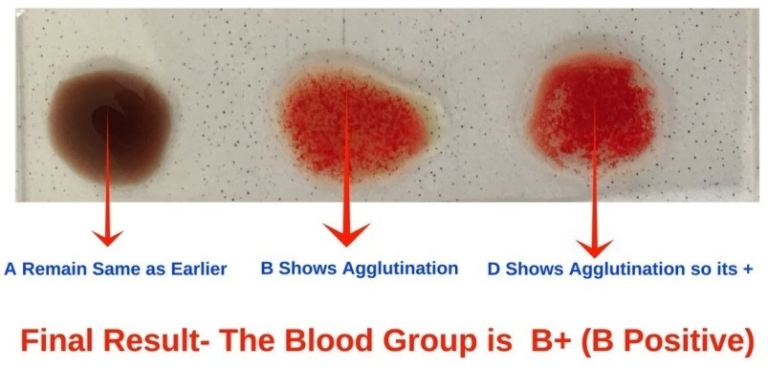**Result:** Result of the blood group test were as follows

* Agglutination observed on the side with anti-B serum and no agglutination observed on the side with anti-A serum: Blood type B
* Agglutination observed with the anti-D serum: Rh Positive

|  |  |  |
| --- | --- | --- |
| A | B | D |
| - | + | + |

**Discussion:** All of the members of our group were afraid to give blood sample. I raised my hand and agreed to give blood sample. I never tested my blood group before. I was little bit panicked. Our lab assistant takes my blood sample in three steps. For this blood group test we need three drops of bloods. But in our first attempt we got only one drop of blood. After that I hold and gave pressure on my ring finger and got enough blood. Another thing we faced that our D reagent was not showing enough agglutination. After mixing up the bloods with reagents we waited for a minute .After one minute A remain the same as earlier and B shows proper agglutination. On the other hand Rh factor determiner D was not enough agglutinated. Then our lab teacher told us to wait for another minute and after two minute of waiting we noticed a proper agglutination on D.